**Enable Multiple RDP Sessions**

1. Log into the server using **Remote Desktop**.
2. Open the start screen (press the Windows key) and type **gpedit.msc** and open it
3. Go to **Computer Configuration > Administrative Templates > Windows Components > Remote Desktop Services > Remote Desktop Session Host > Connections**.
4. Set **Restrict Remote Desktop Services user to a single Remote Desktop Services session** to **Disabled.**
5. Double click **Limit number of connections** and set the RD Maximum Connections allowed to **999999**.

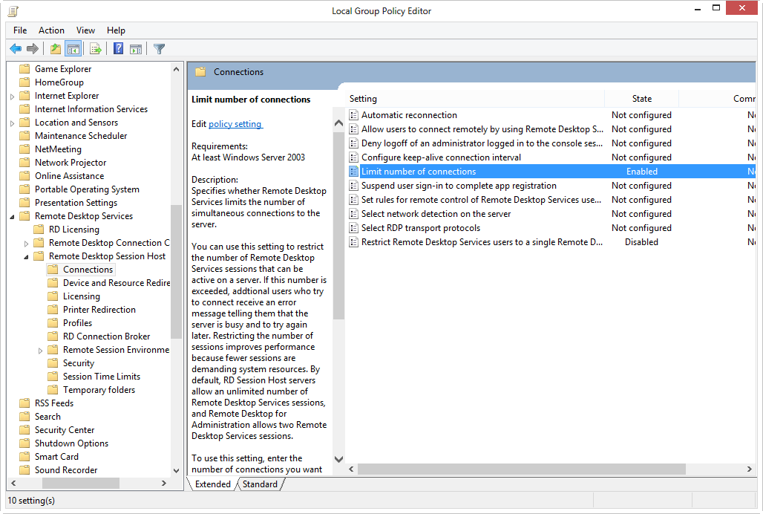

**Disable Multiple RDP Sessions**

1. Log into the server using **Remote Desktop**.
2. Open the start menu and type 'gpedit.msc' and open it
3. Go to **Computer Configuration > Administrative Templates > Windows Components > Remote Desktop Services > Remote Desktop Session Host > Connections**.
4. Set **Restrict Remote Desktop Services user to a single Remote Desktop Services session** to **Enabled.**